CURRICULUM VITAE
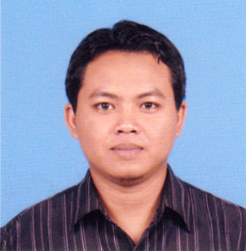

PERSONAL INFORMATION
Name : HARIYANTO
Place, Date Of Birth : Ngawi, 09 May 1984
Height / Weight : 169 / 85
Religion / Nationality : Moslem / Indonesian
Address : Rt.07/Rw.04 Ngadirejo, Gemarang,
Kedunggalar, Ngawi, East Java, Indonesia
Mobile : +6281282868899 / +6282226550449
Email : hariyanto09@hotmail.com
PASSPORT
Number Of Passport : B 0012866
Place, Date Of Issued : Madiun, 24 DEC 2014
Expired : 24 DEC 2019
Number Old Passport : V392524
SEAMAN BOOK
Seaman Book No. : X 058188
Place, Date Of Issued : Jakarta, 09 July 2010
Expired : 09 July 2017
CERTIFICATES/TRAINING
- Basic Safety Training : 6201196071010110
- BOSIET : 137157072311130013. Expired 22/11/ 2017
- Drilling certificate / floorman : 21401708. Expired 25 July 2014
- Heli deck crew member : JDC/SD/1669. Expired 20 Sep 2015
- Forklift Truck Driving C5 : JDC/SD/1688. Expired 20 Sep 2015
- Slinger / Signaler : JDC/SD/1676. Expired 20 Sep 2015
- Confined Space Entry : JDC/SD/1692. Expired 20 Sep 2015
- Stage Induction HSE Modul 7 : 1536-Modul 7-14
- Check-6 Certificate
- Offshore Forklift Operator : No. 0013363

WORK EXPERIENCE

1 Company : SEADRILL
Location : Natuna Sea
Position : Roustabout
Type Rig : Jack Up
Periode : September 2010 – May 2011

2 Company : LINS PETROTAMA ENERGY
Location : Natuna Sea
Position : Roustabout
Type Rig : Jack Up
Periode : September 2010 – May 2011

3 Company : NORTHERN OFFSHORE / ENERGY SEARCHER
Location : CNOCC, well sindoro -1 Arafura Sea
Position : Floorman / Roughneck
Type Rig : Drill Ship
Periode : January 2011 - February 2012

4 Company : UMWSD-NAGA 2
Location : HESS Ujung Pangkah Surabaya
Type Rig : Jack Up
Position : Floorman
Periode : March 2012 – April 2013

5 Company : VANTAGE DRILLING
Location : Total E&P Congo
Type Rig : Ultra Deepwater Drillship
Position : Floorman
Periode : June 2013 –October 2014

